2-D ARRAYS SET 1

Q2) WAP to read an MxN matrix (M<=5, N<=5), and display

a. All elements of a given Row (Row number (between 0 and M-1) will be entered

by the user.)

b. All elements of a given column (Column number (between 0 and N-1) will be

entered by the user.)

c. Element at a given row and column value (Row number (between 0 and M-1) and

Column number (between 0 and N-1) will be entered by the user.

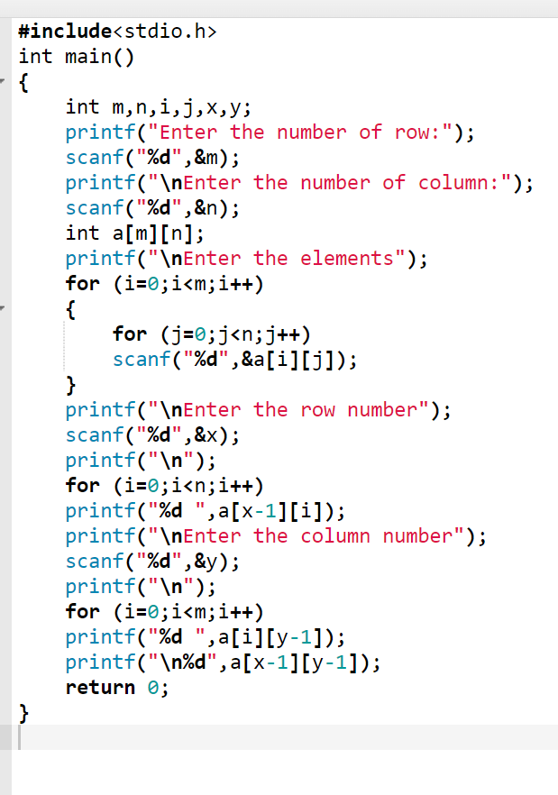

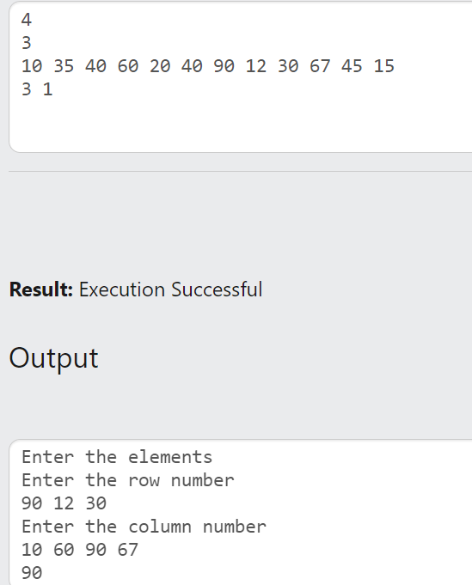

Q3) WAP to read two matrices and do the following: -

a. Addition of matrices

b. Subtraction

c. Scaling a matrix (Multiplying all elements by a given scalar value)

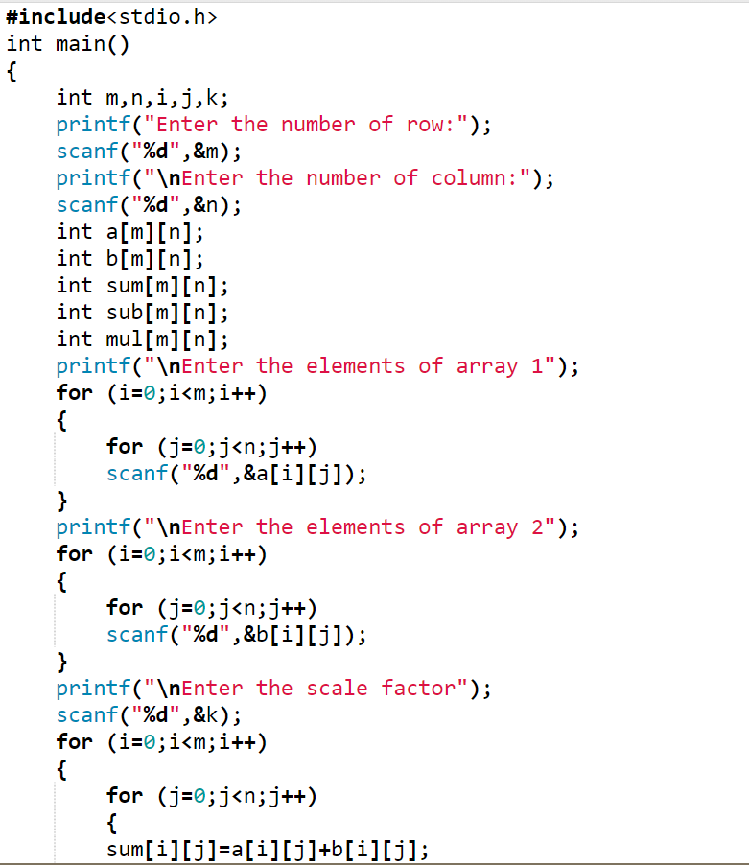

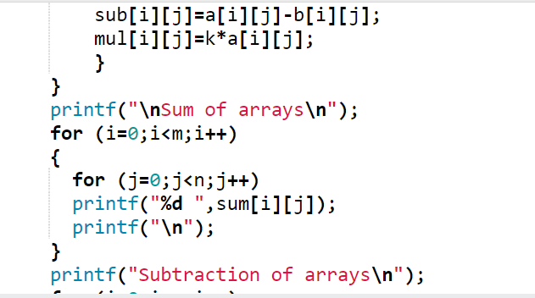

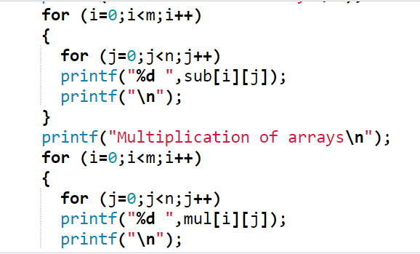

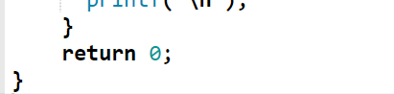

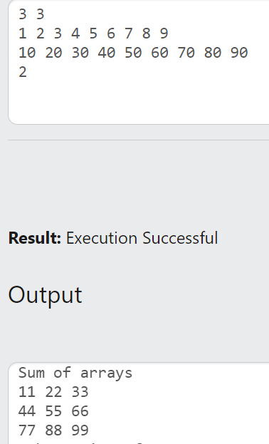 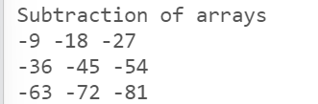 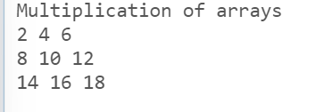

Q4) WAP to find the Transpose of a given matrix.

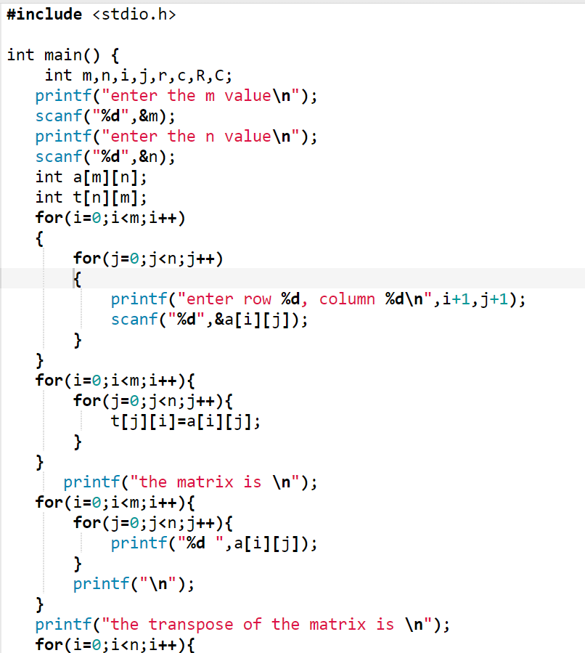

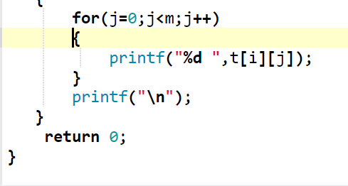

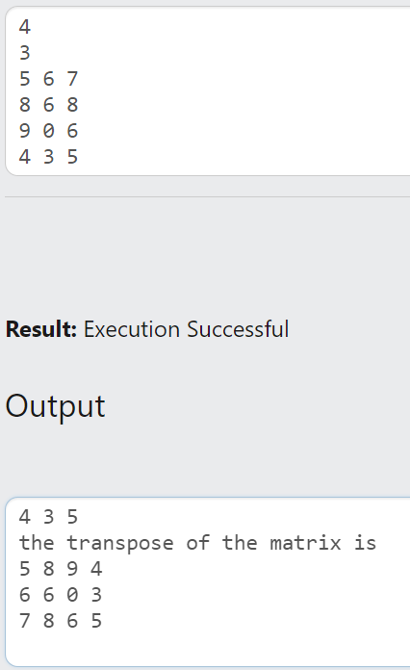

Q5) WAP to read a square matrix and print its diagonal elements alone. (Hint: Use a single loop and put both dimensions as same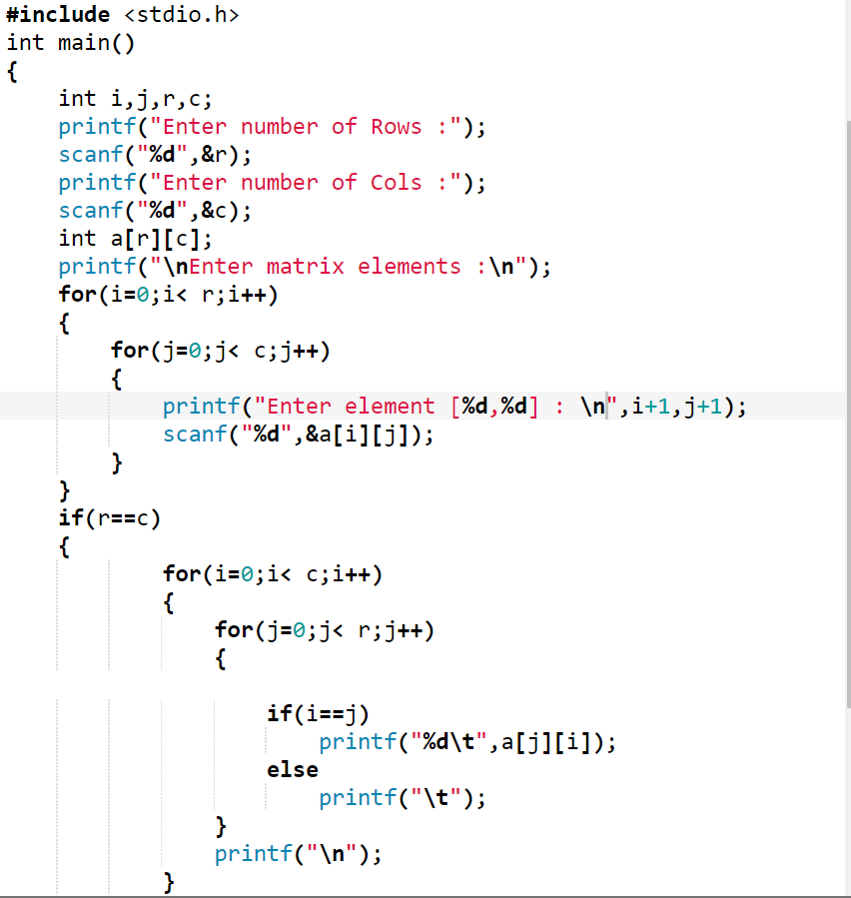

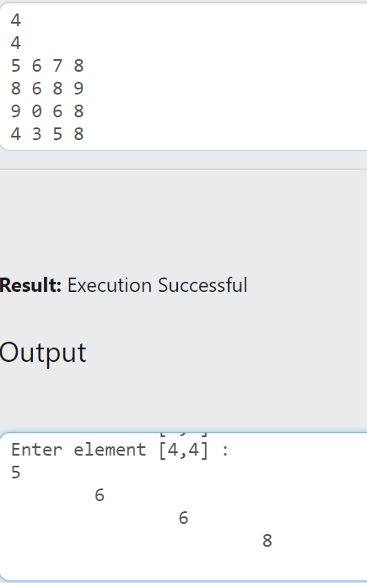

Q6) WAP to read a square matrix and print its trace (sum of diagonal elements).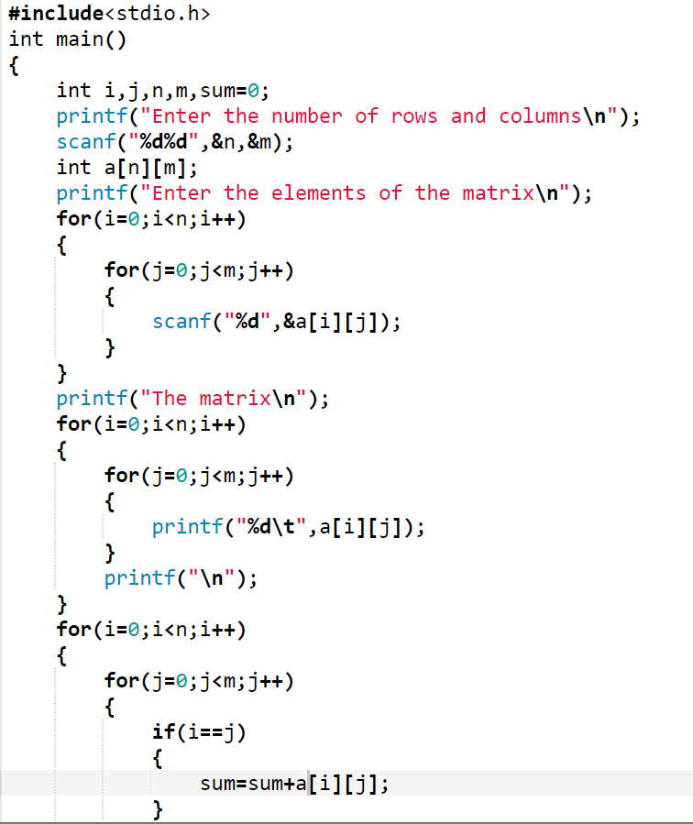

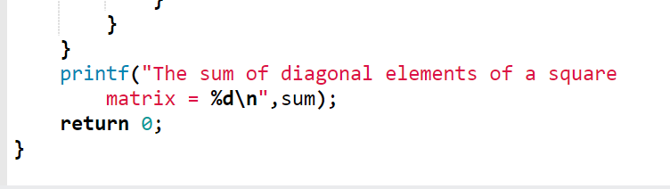

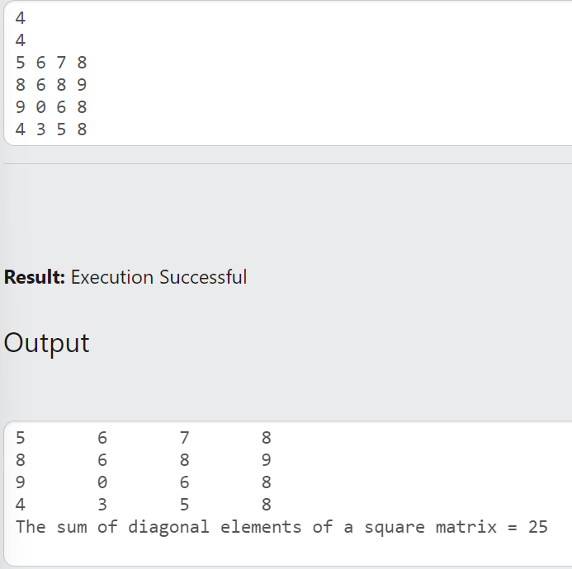

Q7) WAP to enter a square matrix and check whether it is Symmetric (Matrix = Transpose for all elements).

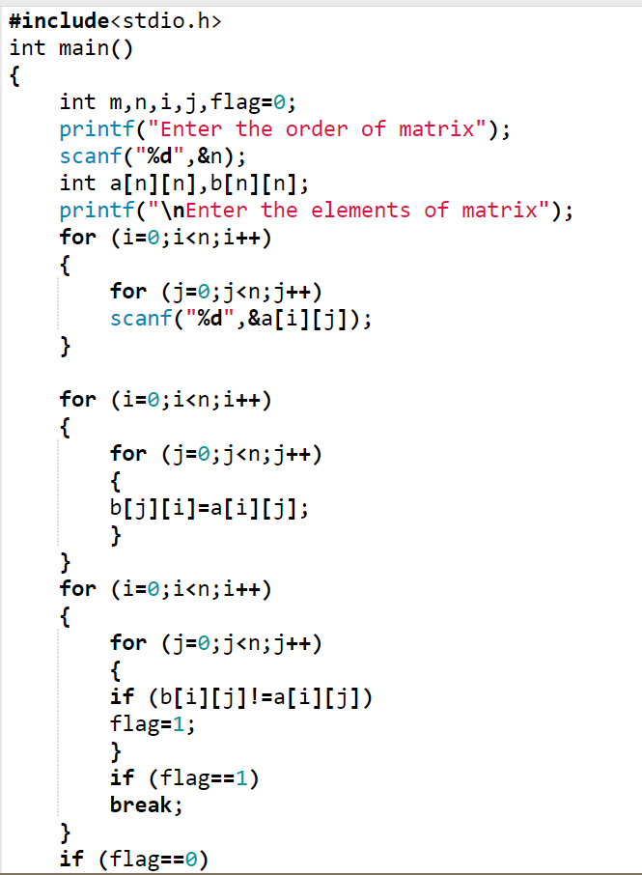

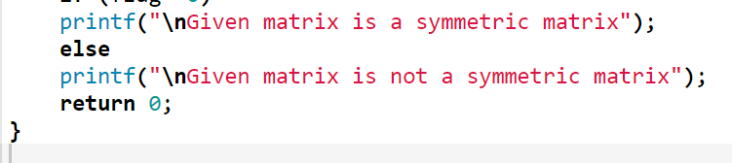

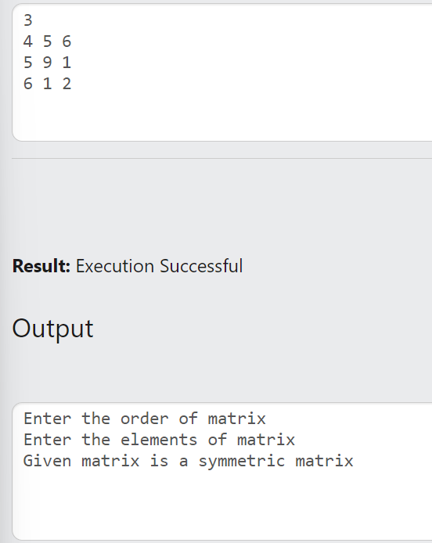

Q8) WAP to enter a square matrix and check whether it is Skew-Symmetric (Transpose element = -(Matrix element))

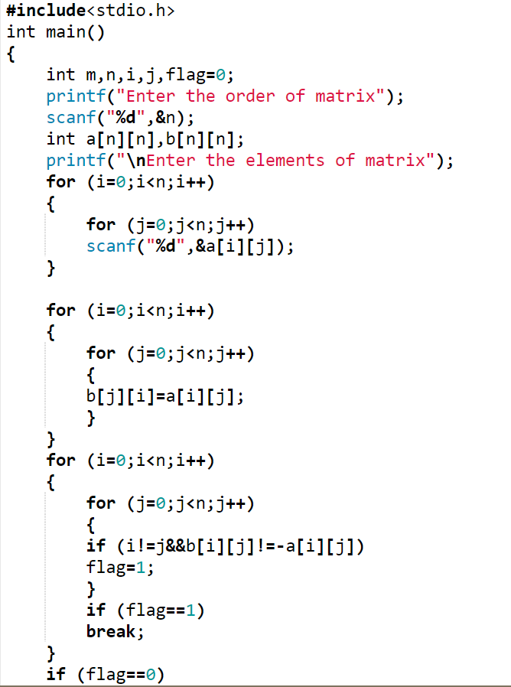

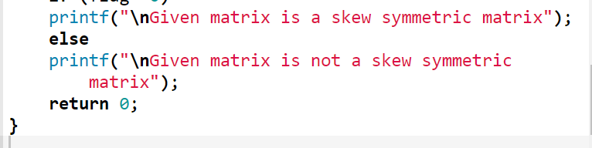

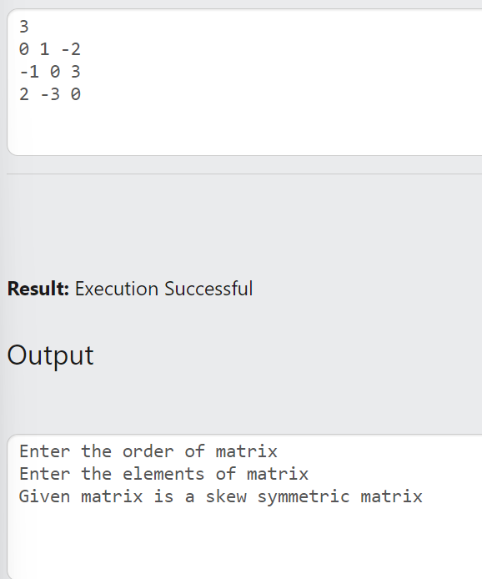

Q9) WAP to enter a square matrix and check whether it is Lower-Triangular (Entry above main diagonal are 0s)

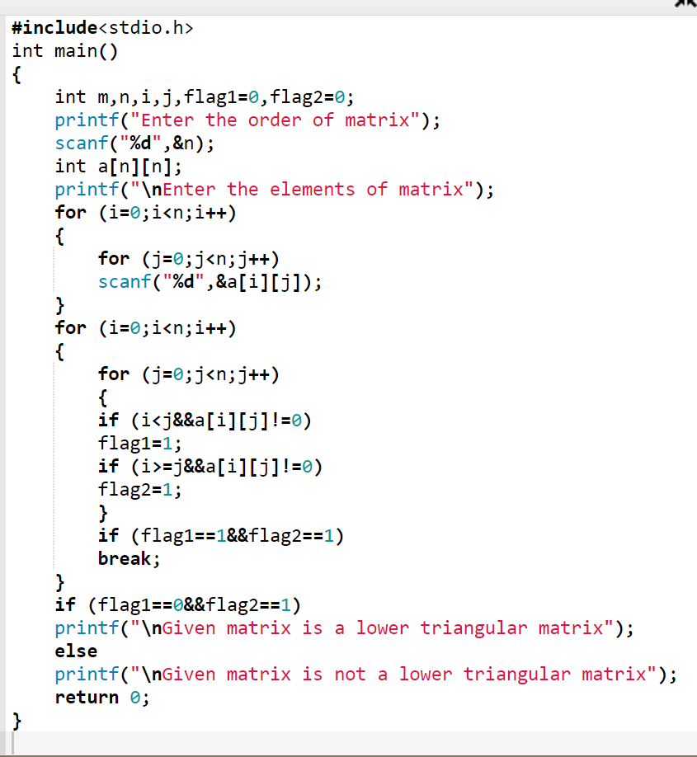

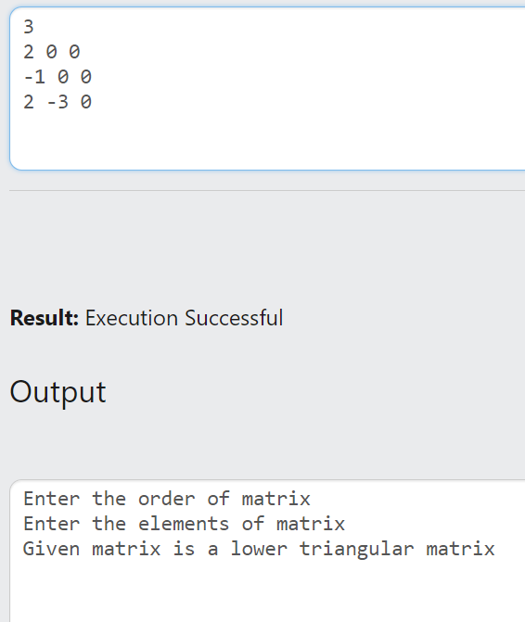

Q10) WAP to enter a square matrix and check whether it is Upper-Triangular (Entry below main diagonal are 0s)

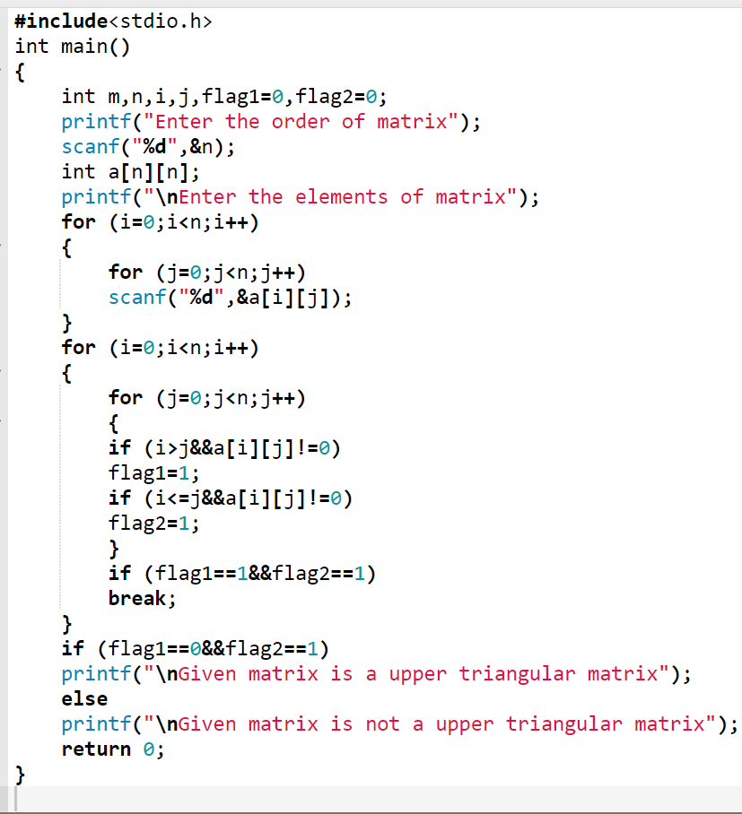

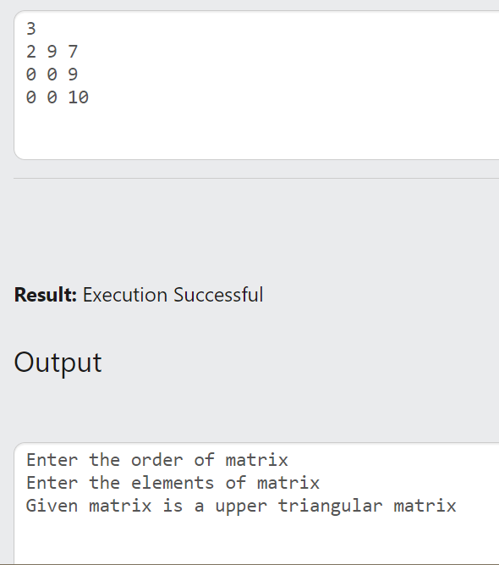

Q11) Write a C program that accepts a square matrix and calculates the sum of the following:

a. each row

b. each column

c. both diagonals

d. lower triangle

e. upper triangle

f. all elements in the matrix

